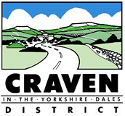
Licensing Act 2003
Minor Variation of
Premises Licence / Club Premises Certificate

Notice is hereby given that [applicants name] have applied to Craven District Council for a minor variation in respect of [name and address of premises].
The nature of the application [state details of the relevant licensable activities including times those activities are to take place or in the case of a variation a brief description of the variation].
Full details of the application can be viewed at the Craven DC Offices, 1 Belle Vue Square, Broughton Road, Skipton,
North Yorkshire BD23 1FJ.
Any person who wishes to make any representations regarding this application should submit their comments in writing to the above address no later than [give date – 10 working days after the day after the licensing authority received the application].
It is an offence to knowingly or recklessly make a false statement in connection with an application. The maximum fine for which a person is liable on summary conviction for the offence is unlimited.
COMPLETION NOTE: Please insert the information requested between the square brackets. The assisting information between the brackets can also be deleted, as can this completion note. A notice is to be provide to the licensing team as well.

