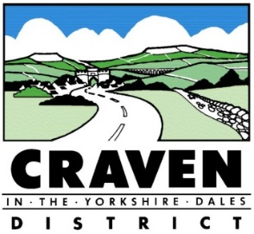HOUSING ADAPTATIONS SERVICE

JOB DESCRIPTION
POST HOLDER:

Vacancy
POST TITLE:

Adaptations Caseworker

JOB TERMS:
37 HOURS 1.0FTE
GRADE: Scale 4/5 £20,092 – £24,491
REPORTS TO:

Housing Adaptations Manager

DATE: June 2021
DEPARTMENT:
Adaptations Service / Environmental Services

JOB PURPOSE

To provide caseworker advice and support to customers in receipt of Adaptation services.

To verify applications – for accuracy of information, compliance with the Housing Renewal Policy, Craven District Council DFG Procedures and Disabled Facilities Grant legislation

DIMENSIONS

Staff Managed: None

Case Loads: As required and agreed to maintain service delivery.

Home Visits: As required and agreed to maintain service delivery.

PRINCIPAL ACCOUNTABILITIES – ADAPTATIONS SERVICE

- CASEWORKER ROLE: Advise and support customers throughout service delivery by collating information to support applications for grants and loans.
- CASEWORK MANAGEMENT: Scrutinise applications (including Provisional Test Of Resources, Tenders, Applications, Completions and payment) to ensure meets legislative and procedural requirements.

PRINCIPAL ACCOUNTABILITIES – CASEWORKER

- Carry out home visits to complete enquiry and application forms.

- Collate all necessary information required to support enquiries/applications for grants and loans e.g. Energy Performance Certificates, Building Insurance, evidence of income and savings etc.

- Carry out checks to support applications e.g. Land Registry property ownership checks, order asbestos refurbishment surveys, Energy Performance Certificates etc.

- Accurately input and update IDOX database and case files.

- Provide advice in relation to housing options available based on the customers individual needs and resources to achieve a sustainable housing solution. Sign post and make referrals as appropriate.

- Support clients to access alternative housing where their present home is unsustainable and/or does not meet their specific needs – via one to one support and/or referral to specialist agencies (e.g. Age UK).

- Provide advice and support on available grants (e.g. energy efficiency grant for loft insulation etc), welfare benefits or other funding opportunities that maximises the customer’s income and improves their general health and wellbeing and sustains their independence to remain in their own home, reduces fuel poverty and increases the energy efficiency of the home.
- To undertake such other duties and responsibilities as would be deemed reasonably commensurate with the level of the post.

PRINCIPAL ACCOUNTABILITIES – CASEWORKER OFFICER

- To visit and support clients applying for financial assistance.

- To verify that information supplied to support DFG and Energy Efficiency Applications is compliant with DFG Legislation, Craven District Council’s ECO Flex and Housing Renewal policies and procedures. This includes all aspects of the Grant process – from enquiry to completion.

- Accurately input and update IDOX database and case files.

- Regularly review caseload to identify delays and problem solve with partners and Manager to progress applications.

SHARED ACCOUNTABILITIES

- Manage a customer caseload and all related correspondence to ensure the customer receives a focused service that meets the required the performance targets.

- To assist the Housing Adaptations Manager to ensure delivery of an efficient and effective Housing Adaptations Service.

- To assist the Exchequer and Performance Manager to promote and deliver the Craven Climate Emergency Strategic Plan 2020 - 2030

CAREER GRADED POST Grade 4/5

In order to progress up the pay scale from Scale 4 to Scale 5:

Competence demonstrated in all areas under ‘principal accountabilities and

STEP 1 – LEGISLATIVELY COMPETENT
To have undertaken the following training:
- Introductory means testing for Disabled Facilities Grants
- Means testing for Disabled Facilities Grant (intermediate)
- Disabled Facilities Grants – Law and Policy
And provide evidence of understanding and implementation of knowledge

STEP 2 – CASEWORKER COMPETENT
To have undertaken the following training:
- Means testing for Disabled Facilities Grants (Advanced)
And provide evidence of understanding and implementation of knowledge

- Ability to case manage and meet targets for delivery
- Achieved thorough knowledge and expertise in all aspects of Grant delivery and use of case management systems

Progression from Scale 4 to Scale 5 to be reviewed as part of the annual Personal Development Review (PDR) process.

ORGANISATIONAL CHART
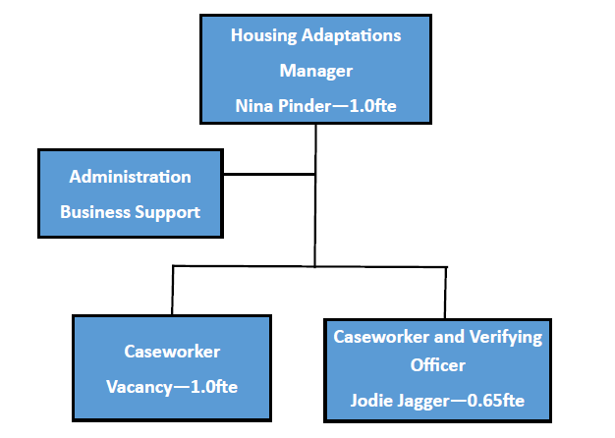

DECISION-MAKING

N/A

SIGN OFF

Job Holder: | Line Manager: Nina Pinder
Signature: | Signature:
Date: | Date:

CRAVEN HOUSING ADAPTATIONS SERVICE

PERSON SPECIFICATION FOR ADAPTATIONS CASEWORKER

REQUIREMENTS | ESSENTIAL  DESIRABLE | METHOD OF IDENTIFICATION
Education/Qualifications  - Good standard of general education to GCSE level (or equivalent)  - Qualified to Degree (or equivalent) standard | Essential  Desirable | Application Form
Experience  - Have experience of at least 2 of the following:  - Working with the public  - Working in a Multi-agency / partnership setting  - Delivering Disabled Facilities Grants or other Grant programme (s)  - Delivering home adaptations or home improvements  - Supporting vulnerable adults  - Working within a Housing legislation framework  - Holding a caseload  - Work involving Disabled adaptation, disrepair or energy efficiency retro-fit measures | Essential | Application Form/Interview
Practical and Intellectual Skills  - Good communication and interpersonal skills  - Ability to make clear written and oral reports  - A knowledge and appreciation of IT applications  - Budgeting skills | Essential  Desirable  Essential  Desirable | Interview  Application Form and Interview  Application Form  Application Form/Interview
Special Knowledge  - At least two of the following:  - Disabled Adaptations  - Energy Efficiency measures  - Grant programmes and processes  - Disabled Facility Grant processes  AND  - Disabled Facilities Grant – Law and Policy | Essential | Application Form/Interview

REQUIREMENTS | ESSENTIAL | METHOD OF IDENTIFICATION
Disposition and Attitude  - Ability to work on own initiative  - Ability to work within a team  - Ability to work to deadlines  - Tactful and diplomatic | Essential  Essential  Essential  Essential | References  References  References  References
Development  - Willing to undertake any training required  - Willing to develop own skills and evidence of personal development | Essential  Essential | References  Application Form
Personal Qualities  - Good level of general health and physical fitness appropriate to the requirements of the post  - Able and willing to work flexibly within a local authority and appreciation of the need to respond to the requirements of a customer driven policy  - Appreciation of and commitment to, equality and diversity in all aspects of Craven District Council’s activities  - A display of many of the behaviours set out in Craven District Council’s Handbook* | Essential  Essential  Essential  Essential | Interview and References  Interview  Interview  Interview
Other  - Full driving licence valid for the UK and access to a vehicle | Essential | Application form

* This document relates to the positive attitude and behaviour expected of employees of Craven District Council.

