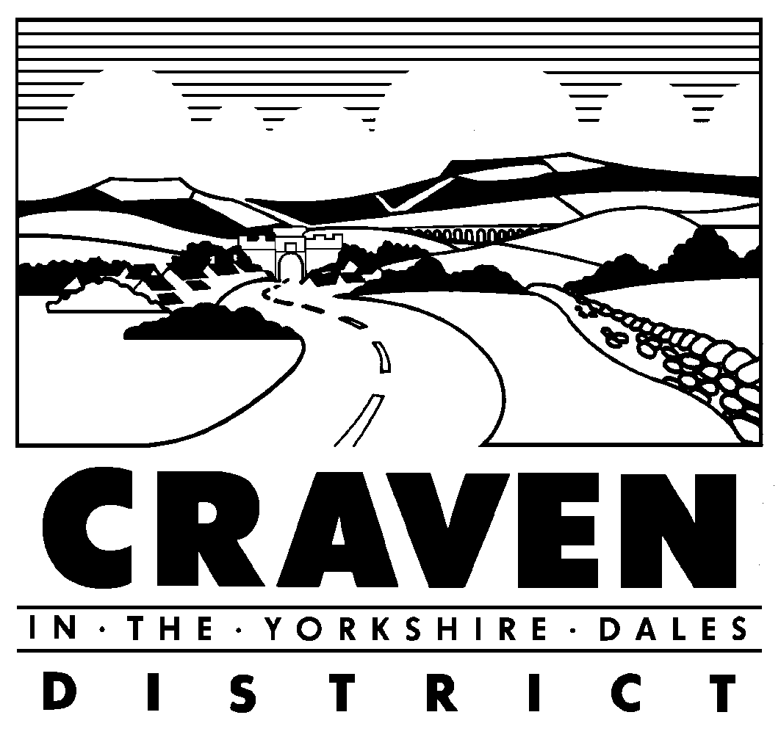

Planning Committee

2 August 2021 at 1.35pm

Meeting Cancelled

Please note that, in agreement with the Chairman and Vice Chairman, the Planning Committee scheduled to take place on Monday 2 August 2021 has been cancelled due to lack of business.

This decision to cancel was taken before the Chief Executive took the decision to cancel all Committee and Council Meetings until the end of August.

The next ordinary meeting of the Planning Committee is scheduled to take place on Wednesday 1st September 2021.

Vicky Davies
E-mail: vdavies@cravendc.gov.uk or committees@cravendc.gov.uk
27th July 2021

