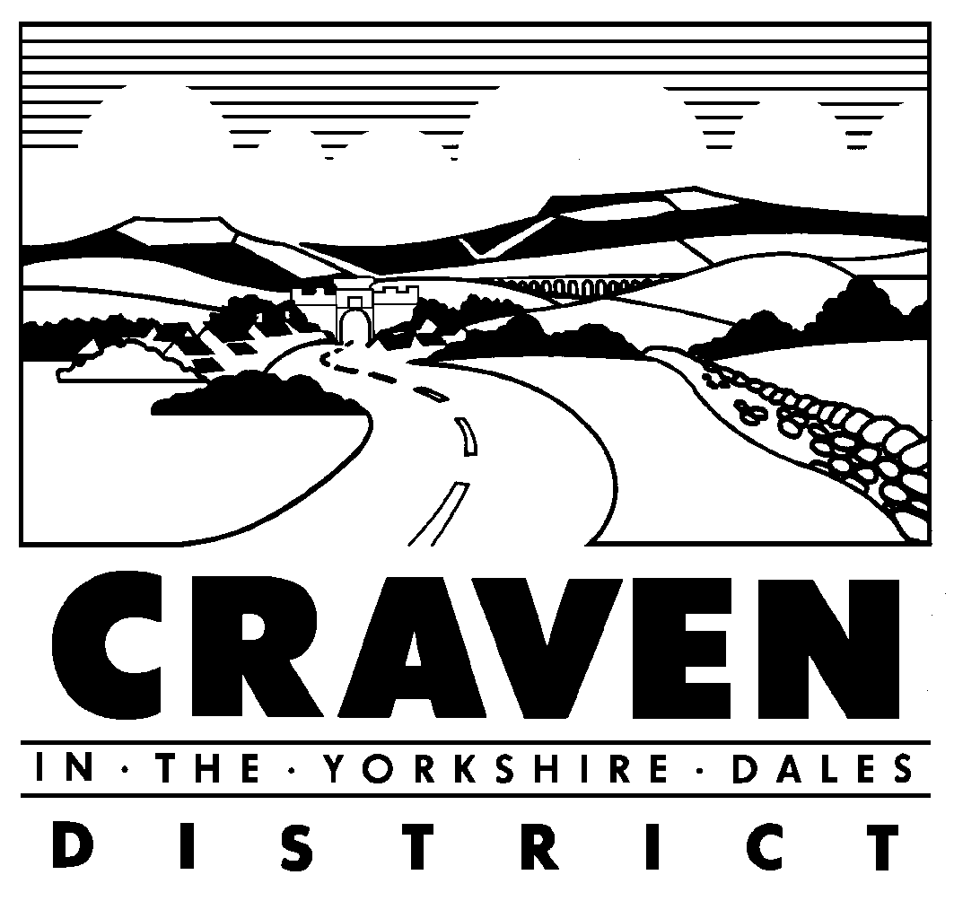

Select Committee

11 August 2021 at 6.30pm

Meeting Cancelled

Please note that, the Chief Executive has taken the decision to cancel all Committee and Council Meetings until the end of August. For urgent decisions, we will be relying on the emergency authority delegated specifically to the Chief Executive in the Scheme of Delegation to Officers and following a similar process to the one we put in place at the beginning of the pandemic.

The next ordinary meeting of the Select Committee is scheduled to take place on 8th September 2021.

Vicky Davies
E-mail: vdavies@cravendc.gov.uk or committees@cravendc.gov.uk
27th July 2021

