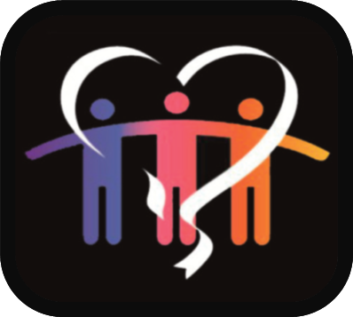
2017
2017
Craven Community Champions
Awards 2021
Nomination Form
Craven Community Champions
Awards 2021
Nomination Form
Craven Community
Champions Awards 2021
Nomination Pack

This will be the 9th year that the Awards have been held, they started back in 2012, organised by Craven District Council in partnership with our award sponsors, many of whom continue to sponsor the awards to this day. These awards really could not take place without the generous support of our 2021 award sponsors Alexander’s Bar & Kitchen, Smart Solutions, Melvin & Co, Keelham Farm Shop, Angus Fire, The Coniston Hotel Country Estate & Spa and Yorkshire Housing.

The awards are our annual celebration to honour outstanding local groups and individuals who go that extra mile to help others and make their communities such great places to live.

Last year was a very difficult year for everyone but it was amazing to see how quickly local people came together to support each other and look after the most vulnerable in their communities. We took a break from the awards last year, but we are back again in 2021 to celebrate all those groups and individuals that have made our communities stronger than ever.

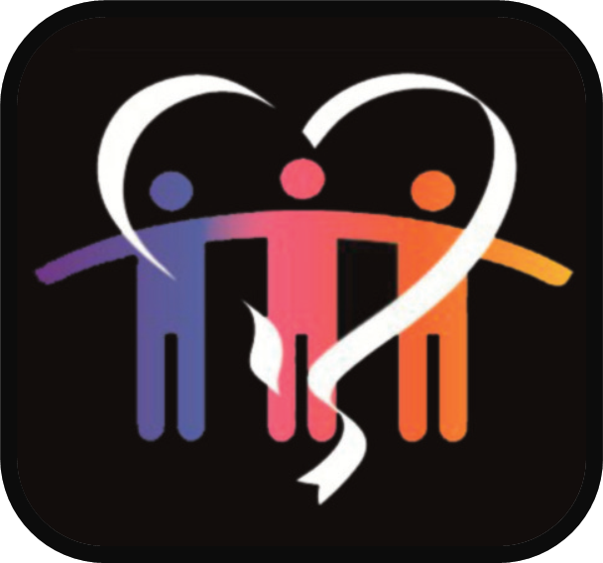
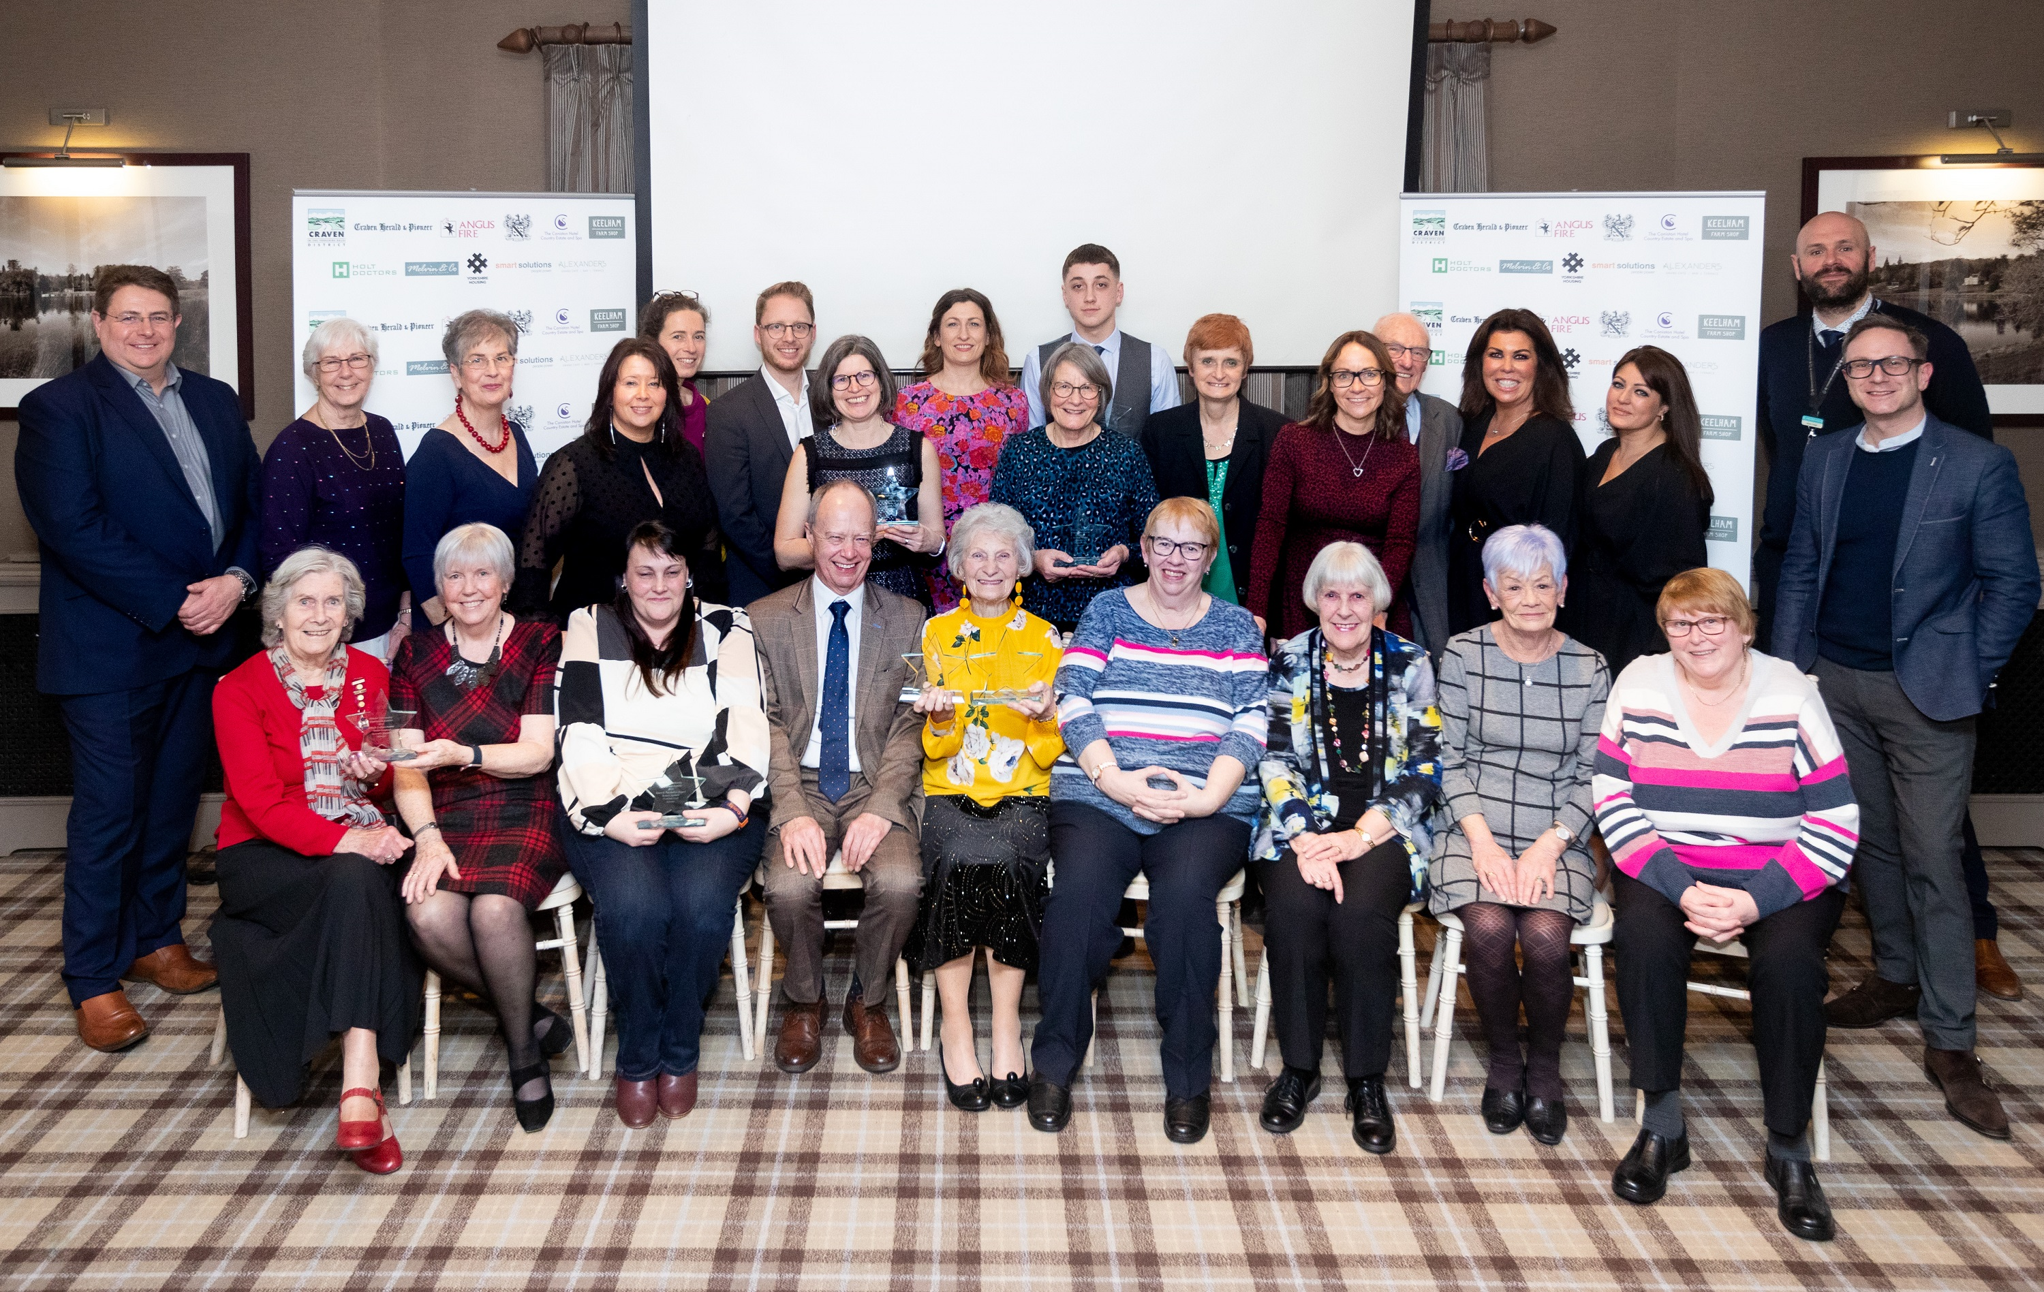
2019 Craven Community Champions Award Winners and Sponsors

If you know of an individual, a voluntary group or an organisation that is making a difference in your community, please show your appreciation by nominating them for an award. The deadline for receipt of nominations is midnight, 11 January 2022.

There will be one winner in each of the eight categories listed over the page.

The winners will be announced on Thursday 3th March 2022 at the Awards Ceremony hosted by the Coniston Hotel and Country Estate at Coniston Cold.

Everyone who has been shortlisted to receive an award will be invited to join us at the Awards Ceremony and help us celebrate our community heroes.

Award Categories

The Arts & Culture Award

Sponsored by Alexanders Grand Café, Terrace and Bar  Alexander's, part of Skipton-based The PEEL Entertainment Group, is an all day dining venue and bar at the top of Skipton’s High Street.  www.alexanders-skipton.com | 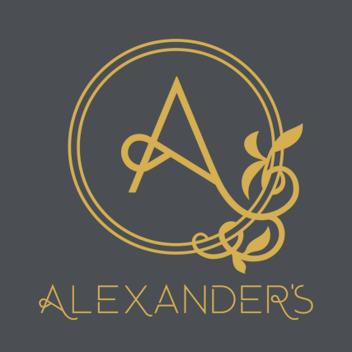

Recognises a community group or individual that have made a contribution to arts, heritage or cultural activities in their community or the wider District.

When judging the application, the Awards Panel will look for examples of how your
nominee has:

- Helped to make arts and culture accessible to everyone in the community
- Been creative in making the most of the resources available to them
- Helped to promote innovation and excellence in the arts

The Greener Craven Award

Sponsored by Smart Solutions  Smart Solutions, delivering people power for recruitment.  www.smartsolutions.co.uk | 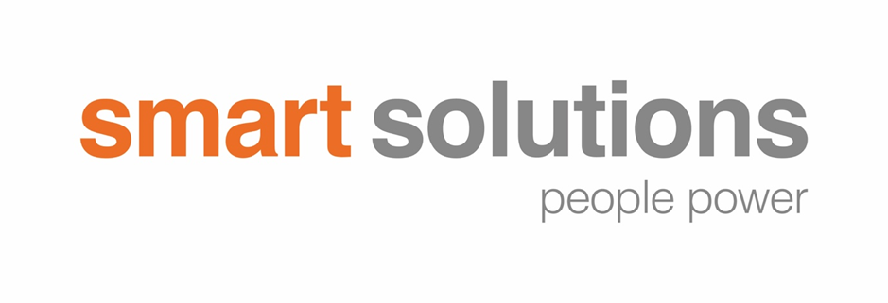
Recognises a community group or individual that have made a contribution to enhancing their local environment or the wider District.

This can include everything from cleaning up a green space to starting a recycling initiative; starting an allotment group to organising a clothes swap.

When judging the application, the Awards Panel will look for examples of how your nominee has:

- Motivated and inspired others to get involved
- Made a positive difference and improved the environment for their community
- Actively promoted environmental issues within their community

The Sport & Recreation Award

Sponsored by Craven District Council  Dedicated to the memory of Bruce Dinsmore in recognition of his unstinting dedication to support community sport and improve sports facilities during his time at Craven District Council.  www.cravendc.gov.uk | 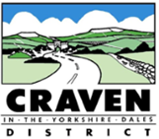
Recognises a community group or individual that have made a contribution to amateur sport or physical activity in their community or the wider District.

When judging the application, the Awards Panel will look for examples of how your nominee has:

- Motivated and inspired others to participate in physical activity
- Helped to make physical activity more accessible to everyone in their community
- Helped to promote excellence in their field of activity

The Health & Wellbeing Award
Sponsored by Melvin & Co  Skipton's Premier Hair Salon offering a full range of Hair Treatments. | 
www.facebook.com/MelvinCoSkipton/

Recognises a community group or individual that has made a contribution to improving the health and wellbeing of local people by providing care to vulnerable people, bringing the community together to look after each other or helping people to live healthier lives in their community or the wider District.

When judging the application, the Awards Panel will look for examples of how your nominee has:

- Made a positive difference to improving the well-being of residents
- Motivated and supported people to live healthier lives
- Brought people together to help vulnerable people in their community

The Best Community Group Award

Sponsored by Angus Fire  A global leader in firefighting technology.  www.angusfire.co.uk | 
Recognises a voluntary or community group that have made a positive impact on people’s lives or has made a significant contribution to their community or in the wider District.

When judging the application, the Awards Panel will look for examples of how your nominee has:

- Made a positive difference to and improved the well-being of a community
- Encouraged new members to get involved
- Made itself accessible and welcoming to everyone in the community

The Volunteer of the Year Award

Sponsored by Keelham Farm Shop  Supporting producers and making a difference in our community.  www.keelhamfarmshop.co.uk | 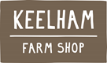

Rewards an individual who has made an outstanding contribution to their community or in the wider District through volunteering in 2018.

When judging the application, the Awards Panel will look for examples of how your nominee has:

- Shown commitment to a cause or organisation
- Acted as a role model/ambassador for volunteering
- Motived and inspired others to get involved in their cause or organisation
- Made a positive difference and has improved the well-being of residents or the community in general

The Young Citizen of the Year Award

Sponsored by The Coniston Hotel Country Estate & Spa  A destination defined by experience.  www.theconistonhotel.com | 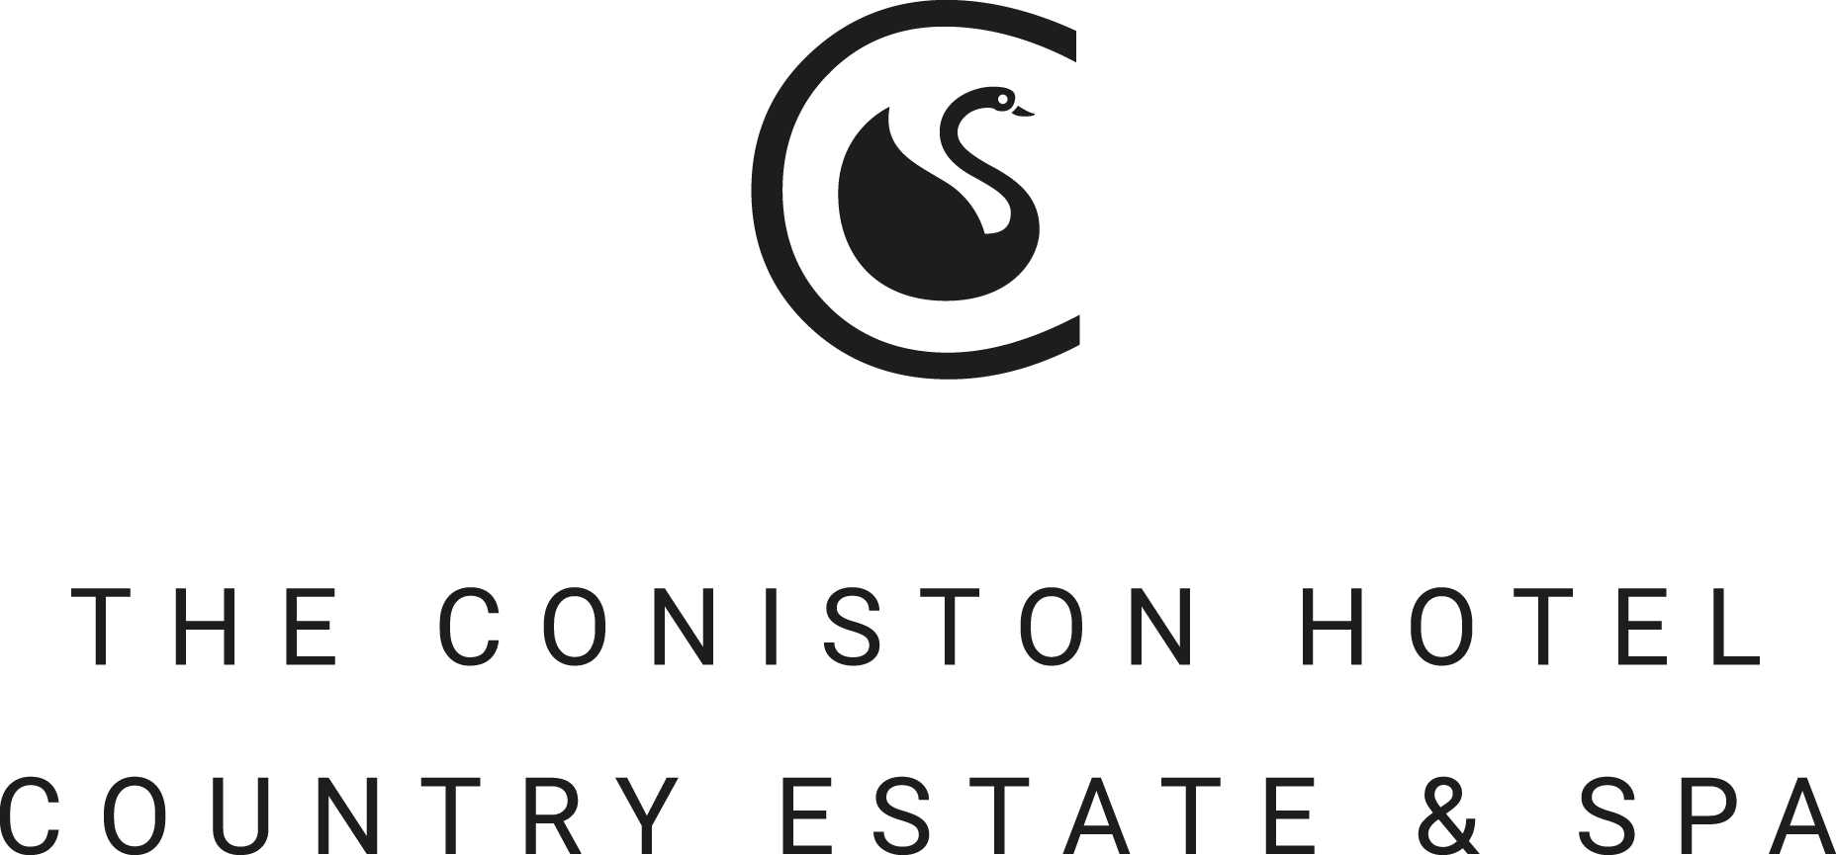

This award is presented to a young citizen in Craven aged between 11 – 25 who has made a positive difference in their community or in the wider District.

When judging the application, the Awards Panel will look for examples of how your nominee has:

- Made a real impact
- Shown exceptional commitment to a cause or organisation
- Brought people together from different backgrounds
- Inspired others by overcoming an obstacle or going beyond the call of duty

The Citizen of the Year Award

Sponsored by Yorkshire Housing  Making it possible  to have a place you’re  proud to call home  www.yorkshirehousing.co.uk | 

This award is presented to an individual who has made an outstanding contribution to Craven during the past year.

The winner of Citizen of the Year is selected from the entries of all of the other categories by the judges.

How to Apply

Anyone can make a nomination by completing the following form and sending it to Craven District Council by midnight, 11 January 2022.

Forms can be sent by email to comms@cravendc.gov.uk or by post to
Craven District Council Craven Community Champion Awards 2021
1 Belle Vue Square Broughton Road SKIPTON North Yorkshire BD23 1FJ

Please read these notes before completing the nomination form.

- Community groups must be made up of two or more people and must provide a specific benefit in a local area. The group may be a branch of, or affiliated to, a larger regional or national organisation, as long as the volunteers started and developed the initiative for the activity in Craven District.

- Community groups or individuals involved in fundraising activities are eligible for an award if their fundraising activity involves volunteers, focuses on creating or holding an event or local activity, and provides something that can be shown to benefit the local community rather than simply asking for donations.

- Each nomination is assessed against the award criteria by the Craven Community Champion Awards Panel. The Panel is made up of independent volunteering and community experts, council and private sector representatives. The decision of the Panel is final.

- The winners will be announced at the Awards’ ceremony and will be presented with a certificate and an inscribed glass award.

- The number of awards available is strictly limited and therefore, however valuable their service, not all the people nominated can receive recognition. It is important for nominators and supporters to realise that an award will not automatically follow the submission of a nomination form.

- Awards are made to people who are still active in the category to which the nomination relates, although there is no bar on an award being made to someone who has recently retired/stood down.

- You may use up to 4 additional pages, but please ensure that you write the name of the nominee and award category on each extra sheet. Additional information could include examples of the nominee’s achievements, photographs, press articles, web links to further information, videos or films. Whilst we will try to return them to you, we cannot take responsibility for their safekeeping.

- Upon receipt of your nomination, we will send an acknowledgement. We regret that it is not possible to enter into correspondence on the merits of a particular nomination, nor on its progress, whilst it is under consideration.

- If there are any important changes to the information supplied on the nomination form after you have submitted it please let us know.
Craven Community
Champions Awards 2021
Nomination Form

Anyone can make a nomination by completing the following form and sending it to Craven District Council by midnight, 11 January 2022.

Forms can be sent by email to comms@cravendc.gov.uk or by post to
Craven District Council Craven Community Champion Awards 2021
1 Belle Vue Square Broughton Road SKIPTON North Yorkshire BD23 1FJ

Name of Group or Individual being Nominated

Award Category
Please tick one award category which best describes your nominated group or individual.

Arts and Culture Award:
An individual or community group that have made a contribution to arts, heritage and culture in their local community or the wider District.
Greener Craven Award:
An individual or community group that have made a contribution to enhancing their local environment or the wider District.
Sport and Recreation Award:
An individual or community group that have made a contribution to amateur sport, physical activity or play in their local community or the wider District.
Health and Wellbeing Award :
An individual or community group that has made a contribution to improving the health and wellbeing of local people by providing care to vulnerable people, bringing the community together to look after each other or helping people to live healthier lives in their community or the wider District.
Best Community Group:
A voluntary or community group that has made a positive impact on people’s lives has made a significant contribution to their local community or in the wider District.
Volunteer of the Year:
An individual who has made an outstanding contribution through volunteering during 2018.
Young Citizen of the Year:
A young person (aged 11 to 25) who has made a positive contribution to their peers, their school or college or a community in general.

Please state in not more than 50 words what your nominee has achieved and why they should receive an award.
(For example, have transformed a derelict area to create a community garden, have given their time freely for over 25 years to help the local scout group or organised an event for the community to raise funds for a new mini-bus for a disabled group).

Please explain how the work of your nominated person or group has benefited their community.

Please describe how your nominated person or group meets the judging criteria for your chosen award which are listed on pages 2-5 of this form.

If you are nominating a group or organisation please tell us.
- When the group was formed.
- What the group was formed to do.
- The number of people who currently use the group.

Contact Details for the Person Making the Nomination
Please provide the following information about yourself.
Your Name:

Your Address:

Your Postcode:

Your Daytime Telephone Number:

Your Email:

Your relationship with, or how you know the nominee:

Signature:

Date:

Contact Details for the Nominee
Please provide the following details about the individual or group you are nominating.

Contact Name:

Address:

Postcode:

Daytime Telephone number:

Email:

Please send your completed form and up to four additional pages of supporting
Information, by midnight, 11 January 2022, to:

E-mail: comms@cravendc.gov.uk or
Post : Craven District Council Craven Community Champion Awards 2021
1 Belle Vue Square Broughton Road SKIPTON North Yorkshire BD23 1FJ

The information contained in this nomination form is strictly confidential and will not be communicated to any person other than those involved in the administration of the Awards with the exception of background information provided overleaf, which may be used in association with the announcement of any award granted.

Please complete the Nomination Form in full. It is important that you provide as much information about your nominated individual, group or organisation as possible, and explain exactly how they contribute to the people and the community they benefit.

If you need help or advice to complete the form, please contact the Awards’ administrator Kate Senior by email at comms@cravendc.gov.uk or by calling 01756 700600.

