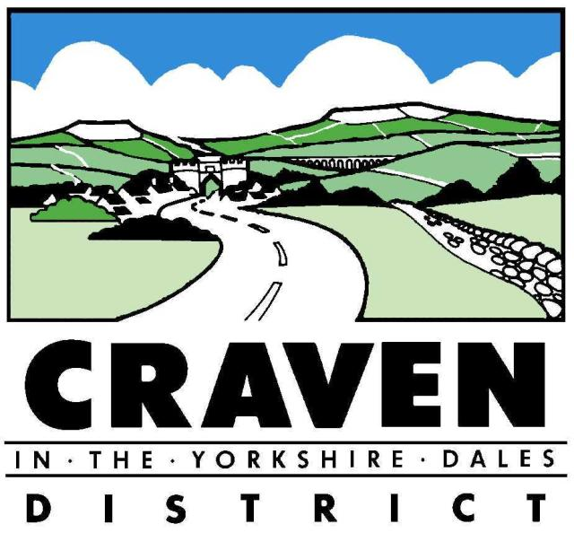

INFRASTRUCTURE FUNDING STATEMENT 2020-21

Published December 2021

CONTENTS
1. Introduction 2
2. Developer Contributions 3
- Section 106 Contributions 4

- Introduction
  - Following amendments to legislation relating to the Community Infrastructure Levy (CIL), (The Community Infrastructure Levy (Amendment) (England) Regulations 2019 No.1103) that came into force on 1 September 2019, Local Planning Authorities are now required to produce an annual Infrastructure Funding Statement (IFS).

  - The Infrastructure Funding Statement (IFS) is an annual report which provides a summary of the financial and non-financial developer contributions relating to Section 106 Legal Agreements (S106) and Community Infrastructure Levy (CIL) within Craven District. As the Council has not introduced a CIL the IFS will not report on this.

  - This IFS relates to the 2020/21 financial year. Previous IFSs and details of S106 contributions received prior to requirement for the Council to publish a IFS is available to view here.

  - Throughout the IFS there will be references to the following definitions:
- Agreed - contributions that have been agreed within a signed legal document but have not yet been collected/delivered because the appropriate trigger point for payment has not yet been reached. If the planning applications are not implemented, they will never be received.
- Received - contributions received, either non-monetary or monetary, that have been
transferred to Craven District Council (CDC).
- Allocated - contributions that have been assigned to specific projects.
- Spent/Delivered - monetary or non-monetary contributions that have been used as
intended, either by spending the allocated funds or completing the contribution as
agreed.
- This financial year - unless stated otherwise, this refers to the period 01/04/2020 -
31/3/2021
1.4 This report provides a summary of both monetary and non-monetary contributions the Council has secured through section 106 agreements from new developments. Whilst many of the S106 agreements signed as part of planning applications often include contributions towards education, highways, public transport, cycleways etc. these contributions are collected, managed and monitored by North Yorkshire County Council and will be reported in their IFS. The S106 contributions received and spent by Craven District Council therefore relate to open space and affordable housing.
1.5 In summary the report provides:
- an overview of S106 agreements;
- the Council's internal process relating to s106 contributions;
- the s106 contributions paid to the Council in the 2020/21 monitoring period;
- projects delivered in the District via s106 agreements in the 2020/21 monitoring period.

- Developer Contributions
Section 106 Planning Obligations
2.1 Under section 106 (s106) of the Town and Country Planning Act 1990 a Local Planning Authority (LPA) can seek obligations, both physically on-site and contributions for off-site, when it is considered that a development will have negative impacts that cannot be dealt with through conditions in the planning permission. Planning Obligations (also known as S106 Agreements) are legal agreements which can be attached to a planning permission to mitigate the impact of an otherwise unacceptable development to make it acceptable in planning terms.
2.2 For example, new residential developments place additional pressure on existing social, physical and economic infrastructure in the surrounding area. Planning obligations aim to balance this extra pressure with improvements to the surrounding area to ensure that a development makes a positive contribution to the local area.
2.3 Regulations state that a planning obligation may only constitute a reason for granting planning permission for the development if the obligation is:
- necessary to make the development acceptable in planning terms;
- directly related to the development; and
- fairly and reasonably related in scale and kind to the development.
2.4 The Council cannot ask for contributions via section 106 planning obligations in certain
circumstances:
"Planning obligations for affordable housing should only be sought for residential developments that are major developments...For residential development, major development is defined in the National Planning Policy Framework as development where 10 or more homes will be provided, or the site has an area of 0.5 hectares or more. For non-residential development it means additional floorspace of 1,000 square metres or more...Planning obligations should not be sought from any development consisting only of the construction of a residential annex or extension to an existing home" (Planning Practice Guidance 2019 023 'Planning Obligations')
2.5 The Council's requirements for S106 planning obligations are set out in adopted Craven Local Plan policy INF1: Planning Obligations, which supports the provision of infrastructure as identified under the following local plan policies:
- H2: Affordable Housing & Affordable Housing Supplementary Planning Document (SPD)
- INF2: Community Facilities & Social Spaces
- INF3: Sport, Open Spaces and Recreation Facilities
- INF5: Communications Infrastructure
- INF6: Education Provision
- INF7: Sustainable Transport & Highways

  - S106 contributions can either be provided on-site, for example through the provision of affordable housing and open space, or off-site in the form of financial payments.
Forecasting
2.7 National guidance suggests that councils should consider reporting on estimated future income where possible. The Council may incorporate the forecasting of developer contributions within future IFSs.
- Section 106 Contributions
Process for Off-site Financial Contributions
3.1 Where it is determined that on-site infrastructure and/or affordable housing required by policy is not appropriate, the Council will request from developers a financial contribution to meet these needs outside of the development site through a S106 obligation. The financial contribution requirements and specific processes are set out in the relevant local plan policy listed in Section 2.
3.2 Once the S106 has been signed, it is an obligation, but it will only be realised if the planning permission is implemented and reaches the trigger point for payment such as commencement or prior to occupation. When the planning permission is granted, the S106 obligation is registered as a land charge which stays with the land, obligating any future owners until the terms are met.
3.3 Any financial contributions received by the Council, but not spent within the timescales set out in the S106 agreement, will be identified during ongoing monitoring and will be refunded in accordance with the specific agreement.
S106 Monitoring Fees
3.4 The Community Infrastructure Levy (Amendment)(England)(No.2) Regulations 2019 now allow Local Authorities to charge a monitoring fee through section 106 planning obligations, to cover the cost of the monitoring and reporting on delivery of that section 106 obligation. Monitoring fees can be used to monitor and report on any type of planning obligation, for the lifetime of that obligation. However, monitoring fees should not be sought retrospectively for historic agreements.
3.5 The regulations allow monitoring fees to be either a fixed percentage of the total value of the section 106 agreement or individual obligation; or could be a fixed monetary amount per agreement obligation; or Authorities may decide to set fees using other methods. However, in all cases, monitoring fees must be proportionate and reasonable and reflect the actual cost of monitoring and authorities must report on monitoring fees in their infrastructure funding statements.
3.6 Craven District Council do not currently charge S106 monitoring fees, however they may be introduced in the future by the Council and if so will be reported on in future Infrastructure Funding Statements.
S106 Contributions 2020/21
3.7 The Community Infrastructure Levy (Amendment)(England)(No.2) Regulations 2019, Regulation 121A, Schedule 2 lists those matters to be included in the Infrastructure Funding Statement.
3.8 All figures below relate to the monies received and spent by Craven District Council between 1/4/2020 and 31/3/2021 (the financial year). Whilst S106s often include financial and non-financial contributions for highway and education related issues, these are collected, monitored and managed by North Yorkshire County Council and will therefore be reported in their own Infrastructure Funding Statement. The information provided in the tables below relates to the specific IFS requirement number in Schedule 2 of the CIL Regulations 2019 (as amended) with the letter reference relating to the specific regulation listed under section 3 of Regulation 121A, Schedule 2.
Reg 3a. | Total amount of money to be provided under any  planning obligations which were entered into during 2020/21 | Between £ 703,100 and £ 666,100 (depending on whether POS is provided on site or not at Anley Crag Business Park, Settle)
Reg 3b. | The total amount of money under any planning obligations which was received during 2020/21 | £ 1,639,745
Reg 3c. | The total amount of money under any planning obligations which was received before 2020/21 which has not been allocated by the authority; | £ 181,787

Reg 3d: Summary details of any non-monetary contributions to be provided under planning obligations which were entered into during 2020/21, including details of:
Reg 3d(i) | In relation to affordable housing, the total number of units which will be provided; | 23 units
Reg 3d(ii) | In relation to educational facilities, the number of school places for pupils which will be provided, and the category of school at which they will be provided; | Information provided by  NYCC in their IFS

Reg 3e | The total amount of money (received under any planning obligations) which was allocated but not spent during 2020/21 for funding infrastructure; | £  Affordable Housing:  £869,447  Public Open Space:  £449,587
Reg 3f | The total amount of money (received under any planning obligations) which was spent by the authority during 2020/21 (including transferring it to another person to spend); | £ 432,260
Reg 3g | In relation to money (received under planning obligations) which was allocated by the authority but not spent during 2020/21, summary details of the items of infrastructure on which the money has been allocated, and the amount of money allocated to each item; | Affordable Housing:  £869,447  (see open data webpage for details)  Public Open Space (POS): £449,587  Children's Equipped Play £144,800  Youth Provision & Informal Play  £138,983  Adult Provision, recreation & playing fields  £120,285  Allotment & Civic & Amenity Space  £45,520

Reg 3h: In relation to money (received under planning obligations) which was spent by the authority during 2019/20, (including transferring it to another person to spend), summary details are provided below:
Reg 3h(i): The items of infrastructure on which that money (received under planning obligations) was spent, and the amount spent on each item;
Infrastructure Type | Spent | Projects
Public Open Space | £ 167,413 | Youth Provision & Informal Play: £14,117  Adult Provision, recreation & playing fields: £142,816  Allotment & Civic & Amenity Space: £10,480  TOTAL: £167,413
Affordable Housing | £ 265,314 | Contributions towards the development of Affordable Housing developments district wide
Total: | £ 432,260

Reg 3h(ii) | The amount of money (received under planning obligations) spent on repaying money borrowed, including any interest, with details of the items of infrastructure which that money was used to provide (wholly or in part); | £ NIL
Reg 3h(iii) | The amount of money (received under planning obligations) spent in respect of monitoring (including reporting under regulation 121A) in relation to the delivery of planning obligations; | £ NIL
Reg 3i | The total amount of money (received under any planning obligations) during any year which was retained at the end of 2020/21, and where any of the retained money has been allocated for the purposes of longer term maintenance (“commuted sums”), also identify separately the total amount of commuted sums held. | £ 1,389,272

This figure does not consider indexation (inflation/deflation) that may be applied when the money becomes due. This figure represents the financial contributions included in S106 agreement signed within 2019/20 which will need to be paid by developers. As payments are usually paid at commencement of development and at different points throughout construction, the money could be received by the Council over a number of years. The figure does not include financial contributions which are set out as a formula rather than a specific sum, and where the contribution will be calculated upon reaching the trigger point and the resulting contribution becomes due. These amounts will be reflected in subsequent IFSs. Occasionally on site provision of infrastructure is agreed within a S106, which then changes to a monetary contribution. Where this happens within the same financial year the IFS will reflect this, however if such a variation is agreed in subsequent years the current IFS will report what was agreed in the original S106 and any variations will be reported in a subsequent IFS.

