Cryptosporidium

This leaflet tries to answer some of the questions you might have about Cryptosporidium infection.

What is it?
Cryptosporidium is a microscopic parasite that is found in untreated water.

What are the symptoms?
The symptoms may vary, but yours may have included:
- diarrhoea–profuse and watery;
- stomach pain and cramps - feeling bloated;
- fever – flue-like with aching limbs; and
- weight loss.
Symptoms can start between 1-12 days after becoming infected.

What about the mess?
- If you have to clear up diarrhoea or other mess, take care and wear rubber gloves. Scoop up what you can with a dustpan or paper towel. Rinse down a WC, don’t use a sink that is used for food preparation or washing up. Wash what is left with cloths, and warm soapy water. Pour dirty water down a WC afterwards. Clean all cloths and equipment with dilute bleach (1 eggcup in a small bucket of warm (not hot) water;
- Wash fouled sheets and clothing straight away. Fold them so that you don’t touch the dirty parts. Wash on as hot a wash as possible. Do not over fill the washing machine;
- Household hygiene is very important, disinfect the WC area particularly the flush handle, basin taps and light switches; and
- Make sure everyone uses their own towel and face cloth.

How did I catch it?
The illness can be caught from:
- drinking untreated water from streams, rivers lakes etc;
- infected people (especially children whose hygiene practices are not good); and
- infected animals such as pet or farm animals.

How long does it last?
Symptoms can last up to 3 weeks.

How is it treated?
There is not a specific treatment for Cryptosporidium.
It is important to keep drinking (clear fluids such as water or dilute squash are a good idea) to stop dehydration.
Plenty of rest will also help.
If you are concerned about the severity of your symptoms or the length of time you have had them, go back to your doctor.

Can I give it to some one else?
Yes!
As the organism appears in faeces, unwashed hands can spread the infection.

When can I go back to work/school/nursery?
If you work with food, are under 5 years old attending school/nursery or care for vulnerable people you should stay away until the diarrhoea has stopped for 48 hours. You must still maintain good personal hygiene when you return.
Other children should not return to school until symptoms have stopped.
What can I do to prevent getting it again?

Food
- If you are ill avoid preparing food for your self or others;
- Make sure all water is properly treated. If the water supply maybe contaminated by animal or human faeces water should be boiled; and
- Be careful not to spread the organism to ready-to- eat food such as cold meats and salad by washing in untreated water.

Wash your hands
Everyone in the household should take care to wash their hands properly with soap and rinse them under running water after using the toilet and …
- after you’ve cleared up diarrhoea;
- after you’ve been nursing ill people;
- after you’ve handled laundry or changed nappies;
- before you cook or eat; and
- often during the preparation of food (especially after handling raw meat.
An antibacterial soap is an additional precaution.

For further information contact
Craven District Council
Environmental Health Unit
Council Offices
Granville Street
SKIPTON
BD23 1PS
Tel: 01756 706350

The Facts about

Cryptosporidium

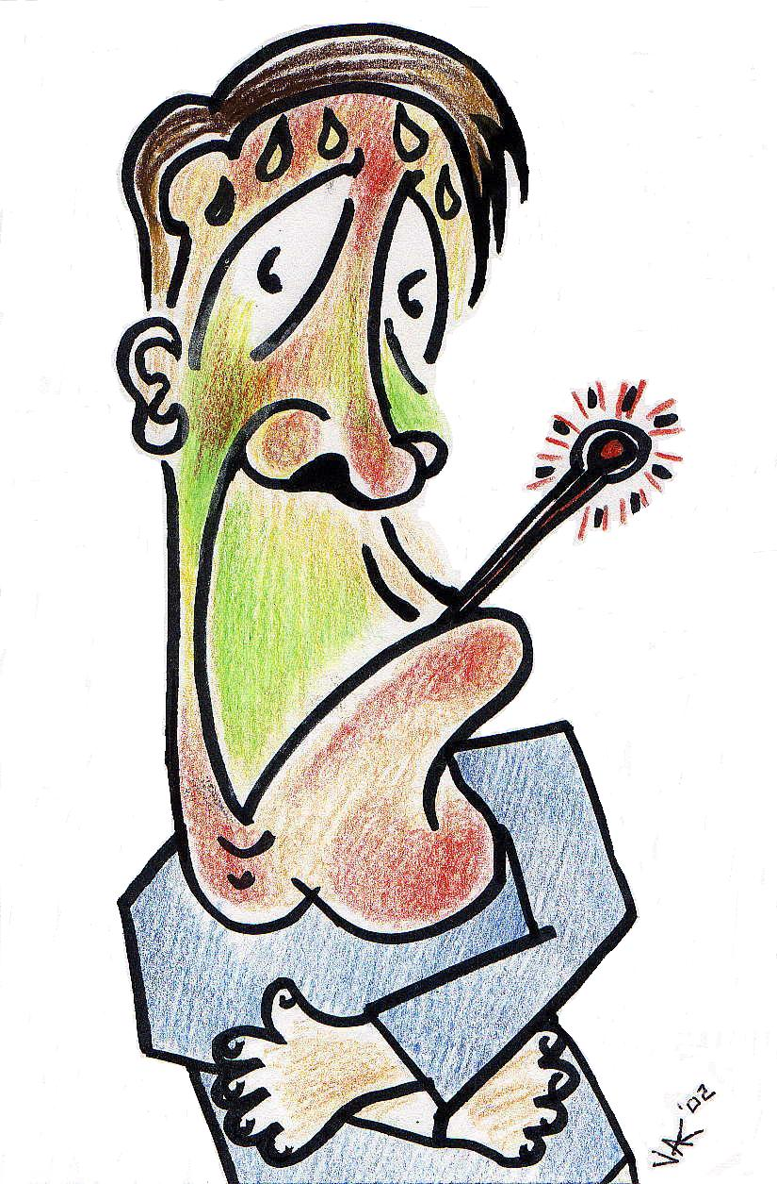

North Yorkshire
Food Liaison Group


