DYSENTERY (Shigella)

This leaflet tries to answer some of the questions you might have about the infection known as dysentery.

What is it?
Dysentery is an infectious disease of the large intestine; there are two types:
Amoebic dysentery – this type is rare in Britain but can be contracted whilst travelling in tropical and equatorial regions of the world where it is common.
Bacterial dysentery – the form most common in Britain, is known as Shigella dysentery and is caused by Shigella, a highly contagious bacteria.

What are the symptoms?
The symptoms may vary, but yours may have included:
- Mild or severe diarrhoea, often containing blood and/or mucous;
- Sickness;
- Stomach cramps; and
- Fever:
Symptoms usually start 1-3 days after becoming infected.

What about the mess?
- If you have to clear up diarrhoea or other mess, take care and wear rubber gloves. Scoop up what you can with a dustpan or paper towel. Rinse down a WC, don’t use a sink that is used for food preparation or washing up. Wash what is left with cloths, and warm soapy water. Pour dirty water down a WC afterwards. Clean all cloths and equipment with dilute bleach (1 eggcup in a small bucket of warm (not hot) water;
- Wash fouled sheets and clothing straight away. Fold them so that you don’t touch the dirty parts. Wash on as hot a wash as possible. Do not over fill the washing machine;
- Household hygiene is very important, disinfect the WC area particularly the flush handle, basin taps and light switches; and
- Make sure everyone uses his or her own towel and face cloth.

How did I catch it?
Very easily!
It takes only a very small number of bacteria to cause the infection. You may have got it from:
- someone else who has the infection, or
- drinking water or eating food contaminated with the bacteria.

How long does it last?
The illness may last for up to two weeks

How is it treated?
It is important to keep drinking (clear fluids such as water or dilute squash are a good idea) to stop dehydration while you have diarrhoea. If you are extremely poorly you should go back to your doctor

Can I give it to some one else?
Yes!
Person to person spread can happen easily if you don’t practice good hygiene. As the organism appears in faeces, hands that are not washed after using the toilet or changing nappies can spread the infection.

When can I go back to work/school/nursery?
If you work with food, are under 5 years old attending school/nursery you should stay away until the diarrhoea has stopped for 48 hours. Those who care for vulnerable people will be asked to provide further faecal specimens (the Environmental Health Officer will advise). You must still maintain good personal hygiene when you return.
What can I do to prevent getting it again?

Food
- If you are ill avoid preparing food for your self or others; and
- Be careful not to spread the organism to ready-to- eat food such as cold meats and salad.

Wash your hands
Everyone in the household should take care to wash their hands properly with soap and rinse them under running water after using the toilet and …
- after you’ve cleared up diarrhoea;
- after you’ve been nursing ill people;
- after you’ve handled laundry or changed nappies;
- before you cook or eat; and
- often during the preparation of food (especially after handling raw meat.
An antibacterial soap is an additional precaution.

For further information contact
Craven District Council
Environmental Health Unit
Council Offices
Granville Street
SKIPTON
BD23 1PS
Tel: 01756 706350

The Facts about

Dysentery
(Shigella)

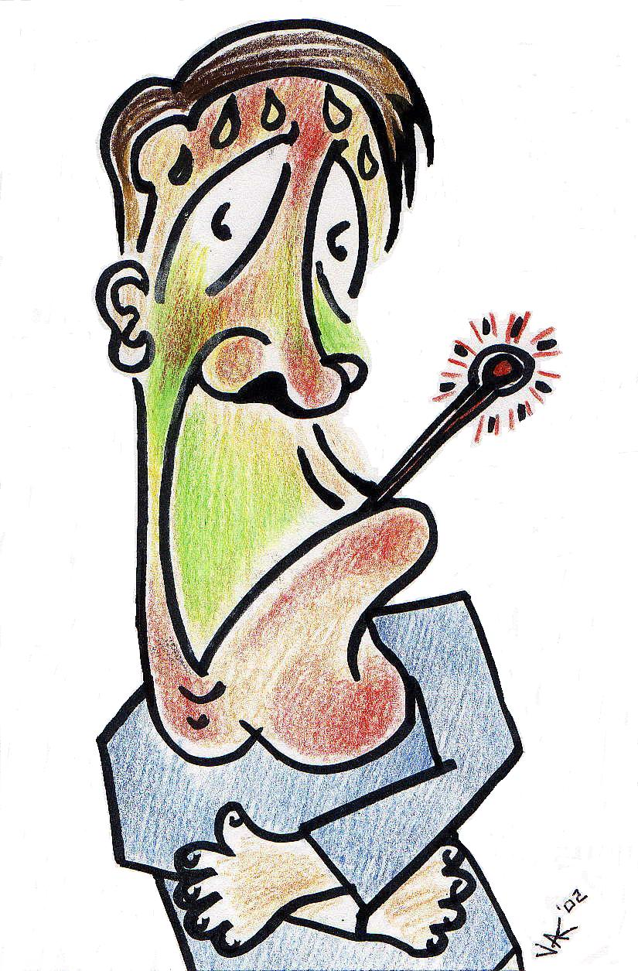
North Yorkshire
Food Liaison Group


