Customer and Benefit Services
1 Belle Vue Square
Broughton Road
Skipton
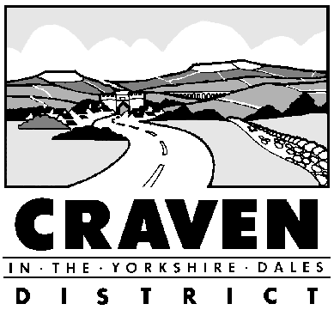North Yorkshire
BD23 1FJ
Telephone: 01756 7000600
Email: localtaxation@cravendc.gov.uk

COUNCIL TAX
APPLICATION FOR DISABLED RELIEF
This form should be completed by the person who is liable to pay the Council Tax. Please read the information overleaf before completing the form.

Property Reference Number: ……………………………………………………………………………….

1. Name of Council Tax Payer ……………………………………………………………………………..

2. Address ……………………………………………………………………………………………………

………………………………………………………………………………………………………………….

3. Name of qualifying individual (see details overleaf)

……………………………………………………………………………

4. What is the person’s disability …………………………………………………………………………..

…………………………………………………………………………………………………………………..

5. Please indicate which of the following apply:

- a room which is not a bathroom, kitchen or lavatory Yes No
- a second bathroom or kitchen Yes No

- a wheelchair which is used indoors by the disabled person Yes No

DECLARATION
I declare that the information given on this form is correct. I understand that I must notify you immediately if there are any changes to the property or household which may affect any reduction I am granted.

Signed (Applicant) ………………………………………. Date …………………………………………….

Daytime telephone number:…………………………………………………………………………………..
For office use only

Date of Visit _________________________________ Inspector ___________________________

Room: Second bathroom / kitchen Wheelchair

Relief granted from ____________________________ Valuation Band _____________________

Reason for not granting relief _______________________________________________________

NOTES

If your home has been specifically adapted to meet the needs of a substantially and permanently disabled resident, you may be entitled to a reduction in the amount of Council Tax you have to pay.

The adaptations that qualify are:

A room (other than a kitchen or bathroom), which has been taken out of normal use and set aside for the disabled person

OR
An extra kitchen or bathroom required to meet the disabled person’s need

OR
Enough floor space to enable a wheelchair to be used indoors

If you think that you may be entitled to a disability reduction on your property, please complete the application form and return to Craven District Council, Local Taxation Team, 1 Belle Vue Square, Broughton Road, Skipton, BD23 1FJ.

The disabled person does not have to be the Council Tax payer, but the application must be made by the Council Tax payer.

We will need to visit your property before deciding if you are entitled to the reduction. If you are, you will receive an amended bill charging you as if your property was in the next lowest valuation band.

If your property is already in the lowest band (A), you will get a reduction of 1/9th of the band D charge.

Until 1st April 2000 you could not apply for a disability reduction if your property was in band A. If you have been turned down for this reason before, you can reapply now.

Please note that telephone calls may be recorded for training and monitoring purposes

