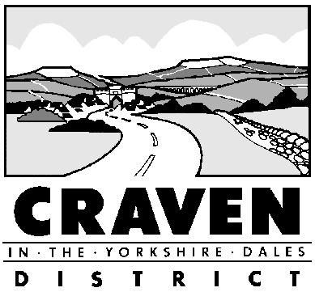
1 Belle Vue Square
Broughton Road
Skipton
North Yorkshire
BD23 1FJ

Telephone: 01756 700600
Fax: 01756 706658
e-mail: benefits@cravendc.gov.uk

HOUSING AND COUNCIL TAX BENEFIT

Notification of Change in Circumstances

FROM:
Name: _________________________________________________________________

Address: _______________________________________________________________

________________________________________________________________________

Your Telephone Number: __________________________________________________

DATE OF CHANGE:

DETAILS OF CHANGE: (Please attach proof as appropriate, and continue on another sheet if you need more space)

Signed: Date:

Notification of
Change of Circumstances

You must tell us immediately, in writing, about any changes to the information used to assess your benefit claim. A phone call or asking someone else to tell us about the change is not enough.

If the change means you would get more benefit, and you do not tell us within one month, we will not be able to backdate the change.

You can use the form overleaf to notify us of your changes. Remember to enter your name and address below where the form states FROM

If there is an overpayment of benefit you may have to pay some money back.

If you deliberately fail to tell us about changes which result in too much benefit being paid, you are committing an offence and you may be prosecuted.

Examples of changes in circumstances you must tell us about:

- changes to your or your partner’s earnings; including changes to the minimum wage;
- changes to your or your partner’s other income, capital or savings;
- changes to the income of any adults or children living with you or the number of people living with you;
- if you, your partner or any other adults in your household stop receiving Income Support or Jobseekers Allowance;
- if any of your children leave college or school;
- if you or someone in your household starts work;
- changes to your tenancy or rent or if you are likely to be away from home for 13 weeks or more

