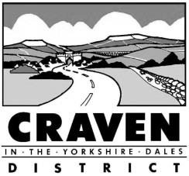
Revised Statement of Community Involvement (SCI) Public Consultation: Tuesday 2nd January 2018 to Tuesday 13th February 2018
Comments Form
Craven District Council invites you to respond to the consultation in whichever format you find best. However, we would encourage you to use this comments form, which we have prepared, because it will help us to record, analyse and acknowledge everyone’s comments more quickly and efficiently.
Name & address (email or postal):

Please return completed forms to localplan@cravendc.gov.uk or Planning Policy Team, Craven District Council, 1 Belle Vue Square, Skipton, BD23 1FJ, no later than 5pm on Tuesday 13th February 2018.
Details of which section of the draft revised SCI you are objecting to/supporting  (section & paragraph number) | Nature of the comment  (object, support, other) | Detail of the comment  (concise and constructive criticism/support/information)

