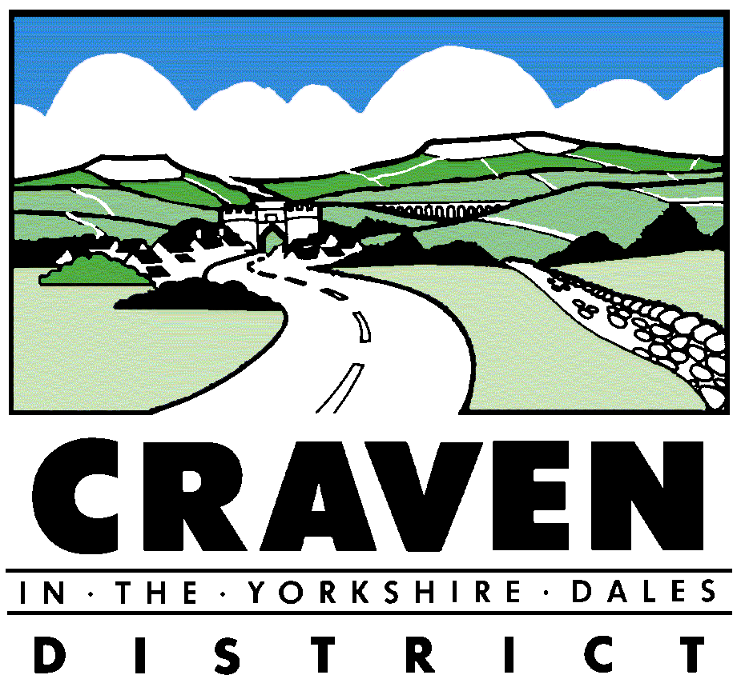

Craven District Council
Equality Objectives 2016 - 2020
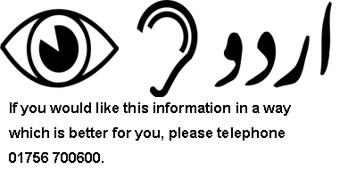

Partnerships Officer
ksenior@cravendc.gov.uk

01756 700600

Approved by Policy Committee: 1st March 2016

Issue 2: February 2017

Craven District Council Equality Objectives 2016 – 2020

The Public Sector Equality Duty which forms part of the Equality Act 2010 requires public bodies such as Craven District Council to set equality objectives. We published our first set of equality objectives by April 2012. We must set and publish further equality objectives at least every four years, so our current equality objectives were published by April 2016.
Our equality objectives should help us to:

- Eliminate unlawful discrimination, harassment and victimisation and any other conduct prohibited by the Equality Act.
- Advance equality of opportunity between people who share a protected characteristic and people who do not share it.
- Foster good relations between people who share a protected characteristic and people who do not share it.

The protected characteristics are age; disability; gender reassignment; marriage and civil partnership (only in respect of eliminating unlawful discrimination); pregnancy and maternity; race; religion or belief; sex (gender); sexual orientation.

Craven is a very rural district and people living outside the larger towns can find it difficult to access services. We will treat people fairly wherever they live and make sure they get the services they need.

There are other factors which affect people’s lives. Examples of these are income, education and occupation. We will work to deliver the best possible outcomes for all our communities and citizens.

We aim to embed equalities thinking into everything that we do. This means that we are able to draw the majority of our equality objectives from equality information that is gathered by service areas through equality analysis, monitoring and consultation. This helps to ensure that our service planning is based on analysis of information and data about the needs of our residents. This helps us to make sure that we use our resources to deliver services that people need and want the most.

The new requirements to publish equality information and to set and publish equality objectives do not ask us to use a set format to do these things. Government guidance is that we are no longer required to produce a single equality scheme and our publication of the Council’s equality objectives should provide people with a good understanding of the actions which we are undertaking to improve life for people with protected characteristics.

This action plan will be regularly updated to ensure it is outcome focused and embedded into everything that we do at Craven District Council. This will allow for actions from equality analysis and monitoring to be regularly fed into the action plan and also local issues allowing our approach to equalities to be focused on local community based information. Our objectives will be reviewed every four years. Equality actions will be fed into service plans and monitored through our usual reporting systems.
Our 2012-2016 equality objectives were published on our website as part of The Craven District Council Single Equality Scheme on the 6 April 2012 informed by:
- Equalities Act 2010.
- Public Sector Equality Duties - Code of Practice to Promote Race Equality (2002) The Duty to Promote Disability Equality: Statutory Code of Practice (2005) / Gender Equality Duty Code of Practice (2007).
- Monthly issues reported to the Craven Rural Network Officer / Rural priorities report (Yorkshire and Humber voice of the voluntary and community sector forum).
- Outstanding actions from Craven Pride 2007 – 2010.
- O & S Disability Review.
- Gypsy and traveller research.
- Public consultation / community engagement activities.
- Equalities Framework for Local Government (EFLG).
- Customer complaints, comments and compliments.
- CLSP Community Engagement and Equalities Group.
- Craven District Council Community Engagement and Equalities Steering Group.

Our Revised Equality Objectives for 2016-2020 were drafted informed by the Annual Equality Report 2014/15 and discussions with North Yorkshire Equality and Diversity Strategic Partnership & North Yorkshire and York Community Engagement Group.

The Draft Revised Equality Objectives were published to our website for consultation between & December 2015.

Notification regarding the consultation was circulated via a press release to the Partnerships and Voluntary Sector database, Councillors, Parish Councils, CDC Community News and Members Information Bulletin.

Following the review and consultation process the Equality Objectives for 2016-2020 were approved by Policy Committee
on 1 March 2016.

Craven District Council Equality Objectives 6 April 2016 - 31 March 2020

Objective 1 : Ensure we embed equalities in the way we provide services

Objective | Action Reference & Name | Timescale | Key Milestones | Key Outcomes | Success Criteria | By Who?
A – Ensure we embed equalities in the way we provide services | Deliver equality and diversity training to members | Annually | Yearly refresher training delivered to members at member training event | Members understand the importance of equality and diversity in relation to service delivery and their public role and the Councils practices. | Member training event held | Dem services
 | Deliver equality and diversity training to staff | Annually | All new staff to receive equalities training as part of induction.  Yearly refresher training delivered to staff | Staff understand the importance of equality and diversity in relation to service delivery and the workplace. | Staff training session delivered | HR
 | Review EIA process as appropriate and use findings to inform EIA training refresher and EIA process & guidance. | 2016 | 1)Undertake historic review of completed EIAs  2) Revise EIA template, guidance, training & wording in Committee report template.  3) Produce EIA report for CLT | Improved quality of EIA’s informed by consultation and data collection leading to service improvements to address equality and diversity needs. | CLT Report produced  Revised EIA guidance produced  Committee report template wording revised | Communications & Partnerships
 | All managers and other appropriate staff to undertake annual Equality Impact Assessment (EIA) refresher training | September 2016 | All managers and other appropriate staff have received EIA training | Improved quality of EIA’s informed by consultation and data collection leading to service improvements to address equality and diversity needs. | EIA refresher training session held  27 managers undertaking training | All Servicers  Communications & Partnerships and HR
 | Monitor the annual number of Equality Impact Assessment (EIA) carried out and report findings to CLT. | Annually | Annual EIA monitoring report produced for CLT | CLT report findings noted and used to improve services. | CLT report produced | CLT  Communications & Partnerships
Objective 2 : Advance equality of opportunity and make sure our services are accessible to all
Objective | Action Reference & Name | Timescale | Key Milestones | Key Outcomes | Success Criteria | By Who?
B – Advance equality of opportunity and make sure our services are accessible to all | Service areas regularly collect equality and diversity information about their customers, where appropriate | Annually | Trends in customer information analysed and reported to CLT and published in Council Equality Report | Service areas use information gathered to improve future service delivery. | Customer information gathered is regularly analysed , reports produced and findings used to improve services. | All departments
 | Review Monitoring Forms and data analysis | June 2016 | Establish which service areas currently monitor customer information and how this information is used to improve services | CLT report findings noted and used to improve monitoring procedures if needed. | CLT baseline report produced | Communications & Partnerships
 |  | September 2016 | Review standard monitoring form for gathering customer information | Monitoring form helps us to gather data which will help improve our service delivery | Revised monitoring form produced | Communications & Partnerships
 |  | October  2016 | All managers to collect customer information using revised monitoring form | A standard set of information is collected about customers across the Council | Customer information gathered is regularly analysed , reports produced and findings used to improve services. | All departments
 | Trends in customer information analysed and reported to CLT and published in Council Equality Report | Annually | Report produced for CLT | Services know their customer base, and ensure that services are accessible to all who wish to use them. CLT informed of customer accessibility information and enabled to make strategic improvements to services to improve access | Improvements in services can be linked to evidenced customer feedback. | CLT Communications & Partnerships
-

