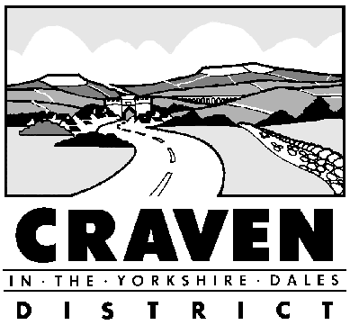Revenues and Benefits Service
1 Belle Vue Square
Broughton Road
Skipton
North Yorkshire
BD23 1FJ
Telephone: 01756 700600
Email: localtaxation@cravendc.gov.uk

COUNCIL TAX APPLICATION FOR EXEMPTION CLASS B
UNOCCUPIED PROPERTY OWNED BY A CHARITY
The Council Tax (Exempt Dwellings) Order 1992 (SI 1992 No. 558), article 3, as amended by The Council Tax (Exempt Dwellings) (Amendment) Order 1994 (SI 1994 No. 539), article 4a, sets out four requirements which must be met in order for a property to be eligible for a Class B exemption:
- The dwelling must be owned by the body in question; and
- the body must be established for charitable purposes only; and
- the dwelling must have been unoccupied for a period of less than six months; and
- the last occupation must have been in furtherance of the objects of the charity

Your property reference:

- This application for a Class B exemption is in respect of
(property address)

- Which was unoccupied from
(date following day of last occupation)

- Until
(date preceding day of first new occupation)

- Declaration
(name and address of organisation)

I declare that the information I have given on this form is true and accurate.
I will tell Craven DC if there is any change of circumstances at my home.
I confirm that I have read and understand the enclosed Privacy Notice.

Name _________________ Position in Organisation ______________________

Signed ________________ Date _______________

Craven District Council Privacy Notice

Council Tax Discounts/Exemptions and Housing Benefit claims
What information do we collect from you?
When you apply for help with your council tax or rent, we may ask you for your name, contact details (home address, email addresses and telephone number) and details of your home, your household and your financial circumstances including bank accounts that you or household have. You may be asked for other personal details, for example about your health. If you are a tenant, we may ask you for details of your landlord.
Why do we collect this information?
Your name and other identifying particulars and your home and personal, household and financial circumstances are needed to confirm your identity and to establish your entitlement to housing benefit and any council tax discounts or exemptions. If you do not provide the information requested, we may not be able to help you with your council tax or rent.
Who might we share this information with?
The Council will not share any of the information that it holds about you with any other third party, without your consent, except where allowed by law. The Council is permitted to share the information that you have provided with other organisations in order to make sure that the information it holds is correct, to protect public funds and to prevent or detect crime. These organisations include the Department for Work and Pensions, HM Revenue and Customs, other local authorities, and certain credit reference agencies.
What do we do with your information?
The information that you have provided will be held by the Council and will only be accessed by authorised Council employees. We will only use the information you have provided for the purpose of your application for help with your council tax or rent, and will not use it for any other Council purpose, unless this is provided by law.
How long do we keep hold of your information?
The Council will keep hold of your information in accordance with the following rules:
- In case of queries, for as long as necessary to deal with any queries (in case your claim is unsuccessful).
- For the duration that your housing benefit claim or your council tax account remains active.
- After your claim or account has ended, based on any legal and regulatory requirements.
How can I access the information you hold about me?
By making a Subject Access Request and going onto the Council’s website at https://www.cravendc.gov.uk/data-and-transparency/data-protection-act/ or writing to the Data Protection Officer, Craven District Council, First Floor, Belle Vue Square, Broughton Road, Skipton, BD23 1FJ. You also have the right to complain to the Information Commissioner’s Office as it can investigate compliance with data protection law: www.ico.org.uk

