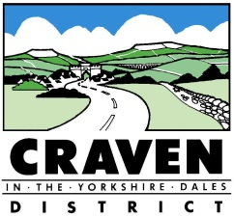
Help with Council Tax for People with Dementia
If you, or another adult in your household, are living with dementia you could be entitled to a council tax discount.
If you have an illness (like dementia) where you have a severe mental impairment, you are ‘disregarded’ for council tax purpose. The actual amount of council tax payable by the household depends upon the number of occupiers. If there are 2 adults in the property, and one is disregarded, the bill will be reduced by 25%. If all adults in a property are disregarded the bill could be reduced by 50% or even 100% (depending on the reasons that people are disregarded). If there are 3 or more adults in the property, and only one is disregarded then there may not be a reduction at all.
Someone is classed as ‘severely mentally impaired’ if they have:
- a severe impairment of intelligence and social functioning which appears to be permanent,
- confirmation of this impairment from a registered medical practitioner, usually the person’s GP or consultant, and
- entitlement to certain disability benefits - the most common qualifying benefits are Attendance allowance (lower or higher rate), Disability living allowance (higher or middle rate care components) and Personal independence payment (lower or higher rate of the daily living component).
Many people with dementia meet all three criteria and are therefore disregarded.
If you think that this disregard might apply to you or someone you know you can apply for the discount online at www.cravendc.gov.uk or you can telephone Customer Services on 01756 700600. You may be asked for additional information or evidence but we can guide you through the process and make sure that you receive the help you’re entitled to.

