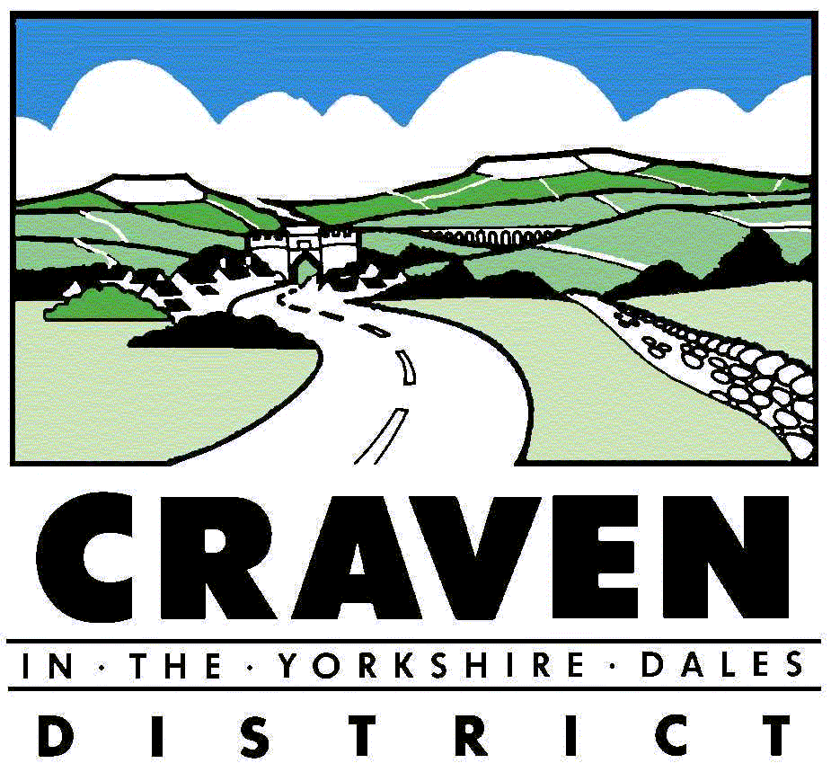
Application for a Scrap Metal Dealers Licence
Section 1 - all applicants
Please indicate the type of licence you are applying for (please tick)

Site Licence Collector’s Licence

Are you applying as (please tick)

An individual A company A partnership

Please state your trading name

___________________________________________________

Is this application for a grant of a new licence or a renewal (please tick)

New Licence Renewal Licence

If renewal please provide details of your existing licence number

___________________________________________________

Section 2 Permits, Registration and licences in force
Please provide details of any relevant Environmental Permit, exemption or registration (such as a scrap metal dealer or motor salvage operator) in relation to the applicant
(continue on separate sheet if necessary)

Type ___________________ ID No. ________________ Issue date _________________

Type ___________________ ID No. ________________ Issue date _________________
Please provide details, including licence number, of any other scrap metal licence issued by any authority to the applicant within the last 3 years
(continue on separate sheet if necessary)

________________________________________________________

________________________________________________________

Are you registered as a waste carrier? (please tick)

Yes No
If ‘yes’ please provide your waste carriers registration number

________________________________________________________

Section 3. TO BE COMPLETED IF APPLYING FOR A SITE LICENCE
N.B. A site licence authorises the licencee to carry on business at a site in the authority’s area. You can apply to licence multiple site using this form
Details of prospective licence holder
Title (please tick) I am 18 years old or over (please tick)

Mr Mrs Ms Other* Yes No

(*please state) ___________________________ Date of Birth ______/_____/___________

Surname: ____________________ Forename/s_____________________________________

Position/Role in the business ____________________________________________________

I attach a Basic Disclosure Certificate issued for the applicant by Disclosure Scotland

Yes No

If you do not provide a Basic Disclosure Certificate your application may be delayed or rejected

Contact details (we will use your business address for all correspondence unless you indicate we should use your home address)
Business Name: ____________________________________________________________

Telephone Numbers:
Address:______________________________________ Daytime: ______________________

_____________________________________________ Evening: ______________________

_____________________________________________ Mobile: ______________________

Post Code _________________ Email:___________________________________________

Home Address: _____________________________________________________________
(if different from business address)
Telephone Numbers:
______________________________________________Daytime: ______________________

______________________________________________ Evening: ______________________

______________________________________________ Mobile: ______________________

Post Code _________________ Email:____________________________________________

Site details: Please list the details for each site where you propose to carry on business as a scrap metal dealer in this local authority area. If you operate more than two sites in the area please provide details for all other sites on a continuation sheet.
N.B. If the applicant operates multiple sites within a licensing area, provision should be made for more than one site manager
Site 1 | Site 2
Business Address  ___________________________________  ___________________________________  ___________________________________  Post Code __________________________  Telephone No_______________________  Email ______________________________  Website ____________________________  Site Manager  __________________________________  (if different from applicant)  Home Address  (if different from business address)  ___________________________________  ___________________________________  ___________________________________  Post Code _________________________  Telephone No _______________________  Mobile _____________________________  Email ______________________________  Basic Disclosure Certificate attached  Yes No | Business Address  ___________________________________  ___________________________________  ___________________________________  Post Code __________________________  Telephone No _______________________  Email ______________________________  Website ____________________________  Site Manager  ___________________________________  (if different from applicant)  Home Address  (if different from business address)  ___________________________________  ___________________________________  ___________________________________  Post Code _________________________  Telephone No _______________________  Mobile Number ______________________  Email ______________________________  Basic Disclosure Certificate attached  Yes No

Partnerships: If you are applying as a partnership, please provide the following details in respect of each partner. Where there are more than two partners please use a continuation sheet.
Partner 1 | Partner 2
Full Name ________________________  Address _________________________  _________________________________  _________________________________  Post Code ________________________  Telephone No ____________________  Mobile __________________________  Email ____________________________  Basic Disclosure Certificate attached  Yes No | Full Name __________________________  Address ___________________________  ___________________________________  ___________________________________  Post Code __________________________  Telephone No _______________________  Mobile _____________________________  Email ______________________________  Basic Disclosure Certificate attached  Yes No

Companies: If you are applying as a company please provide the details set out below
Company Name: ________________________________________________________

Company Registration Number ________________________________

Registered Address _____________________________________________________

______________________________________________________________________

______________________________________________________________________

Post Code ____________________________

Please provide the following details for each director(s), Shadow director(s) and company secretary where these are different from the applicant and site manager(s). Where necessary please use a continuation sheet
Name ______________________________  Role ______________________________  Date of Birth ______/______/____________  Home Address _______________________  ___________________________________  ___________________________________  ___________________________________  Post Code __________________________  Basic Disclosure Certificate attached  Yes No | Name ______________________________  Role ______________________________  Date of Birth ______/______/____________  Home Address _______________________  ___________________________________  ___________________________________  ___________________________________  Post Code __________________________  Basic Disclosure Certificate attached  Yes No
Please provide details of any site in the area of any local authority at which the applicant carries on business as a scrap metal dealer or proposes to do so

Address _________________________________________________________________

________________________________________________________________________

________________________________________________________________________

Post Code _____________________________

Name of the local authority which has licenced this site, or to whom applications have been made before commencement of the Scrap Metal Dealers Act 2013

Name of Authority _________________________________________________________

Do you have planning permission to operate as a scrap metal dealer?
(only applicable to sites established after 1st November 1990)

Yes No Not Applicable

Section 4: TO BE COMPLETED IF APPLYING FOR A COLLECTOR’S LICENCE
N.B. A collector’s licence authorises the licencee to carry out business as a mobile collector in the local authority’s area only
Details of prospective licence holder
Title (please tick)
I am 18 years old or over (please tick)
Mr Mrs Ms Other* Yes No

(*please state) ___________________ Date of Birth _______/______/__________

Surname: _________________________ Forename/s_________________________________

Position/Role in the business _____________________________________________________

I attach a Basic Disclosure Certificate issued for the applicant by Disclosure Scotland

Yes No

If you do not provide a Basic Disclosure Certificate your application may be delayed or rejected
Contact details (we will use your business address for all correspondence unless you indicate we should use your home address)
Use Home Address
Business Name: _______________________________________________________________

Telephone Numbers:
Address:___________________________________ Daytime: __________________________

__________________________________________ Evening: __________________________

__________________________________________ Mobile: __________________________

Post Code ___________________ Email: _________________________________________

Home Address: ______________________________________________________________
(if different from business address)
Telephone Numbers:
___________________________________________ Daytime: ________________________

___________________________________________ Evening: ________________________

___________________________________________ Mobile: _________________________

Post Code __________________ Email:__________________________________________

Please provide details of where will any scrap metal that has been purchased be stored before further disposal

Address _____________________________________________________________________

________________________________________________ Post Code ___________________

Scrap metal will not be stored

Section 5: Vehicle details (Collectors)
Details of vehicle/s to be used: If necessary please use a continuation sheet

Vehicle Registration Number ____________________________

Vehicle make and model ______________________________________________

Where is the vehicle stored when not in use?

_____________________________________________________________________

_____________________________________________________________________

Post Code _________________________

Section 6: Motor Salvage (All applicants)
Will your business consist of acting as a motor salvage operator? This is defined as a business that:

- Wholly or in part recovers salvageable parts from motor vehicles for re-use or
re-sale, and then sells the rest of the vehicle for scrap

- Wholly or mainly involves buying written-off vehicles and then repairing and selling them off; and

- Wholly or mainly buys or sells motor vehicles for the purpose of salvaging parts from them or repairing them and selling them off

Yes No

Section 7: Bank Account(s) details (All applicants)
Please provide details of the bank account(s) that will be used to make payments to suppliers, in accordance with Section12 of the Scrap Metal Dealers Act 2013. If more than two bank accounts will be used, please use a continuation sheet.
Name the account is held in:  ___________________________________  Sort Code: _______ /_________/________  Account Number _____________________ | Name the account is held in:  ___________________________________  Sort Code: _______ /_________/________  Account Number _____________________

Section 8: Criminal Convictions (All applicants)
Have you, any listed directors, partners or site manager(s) in this application ever been convicted of a relevant offence or been subject of and relevant enforcement action? (please see below for a list of relevant offences). If ‘yes’ you must provide the following details for each conviction. If necessary please use a continuation sheet.

Yes No

Name __________________________ Date of the conviction _____________________

The name and location of the convicting court __________________________________

Details of the offence of which you were convicted

_______________________________________________________________________

Sentence imposed _______________________________________________________

Section 9: Payment of fees (All Applicants)
Site Licence £420.00

Collector’s Licence £200.00

Fees should be by cheque and made payable to ‘Craven District Council’.

Section 10: Photograph (Collectors)
You must provide a passport size photograph with a signed statement on the reverse confirming that the image on the photograph is a true likeness of the applicant.

Section 11: Declaration (All applicants)
The information contained in this form is true and accurate to the best of my knowledge and belief. I understand that if I make a material statement knowing it to be false, or if I intentionally make a material statement which is knowingly false, I will be committing an offence under Schedule 1 Paragraph 5 of the Scrap Metal Dealers Act 2013, for which I may be prosecuted, and if convicted, fined.

I understands that Craven District Council to whom I make this application may consult other agencies about my suitability to be licenced as a scrap metal dealer, as defined in Section 3(7) of the Scrap Metal Dealers Act 2013, and that those other agencies may include other local authorities, the Environment Agency, Natural Resources Wales, the Police and any other agency where considered appropriate for the purposes of determining my suitability to operate as a licenced scrap metal dealer.

I understand that the purpose of sharing any information contained in this application is to form a full assessment of my suitability to be licenced as a scrap metal dealer. I also understand that the sharing of information about me may be extended to sensitive personal data, such as data about and previous criminal offences. Some details will also be displayed on a national register, as required under the Scrap Metal Dealers Act 2013. I hereby expressly consent to this processing of my data and display of relevant information on the public register.

Signed: ________________________________________________________________

Please print full name: ____________________________________________________

Dated: ________________________________________________

